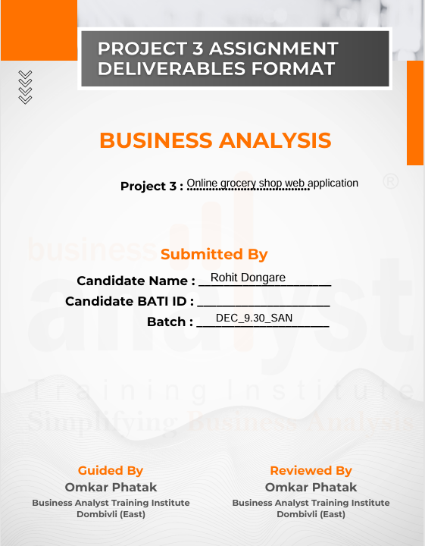

Contents

1. Project scope document: 2
2. Module 7
3. Key features: 10
4. Technology and framework: 13
5. Proof of concept: 14
6. Project estimation: 19
7. Project team: 21
8. Business Requirement document: 22
9. Software requirement specifications 40

# Grocery shop web application:

# Project scope document:

|  |  |  |  |
| --- | --- | --- | --- |
| **Product Features of Customer** | | | |
| **Category** | **Section** | **Actions** | **Sub-Actions** |
| **Authentication** | Login | Login | Enter credentials (email/username, password) & Authenticate. |
| **Purchase** | Purchase the product | Buy now | pay the money and add address |
| **Registration** | Register | Register | Submit registration details. |
| **Refund** | Demand for refund | Demand for refund | Enter refund reason |
| **Profile** | Edit Profile | Edit Profile | Change the necessary details and submit |
| **Order** | Create/Update/Delete Booking | Create/Update/Delete Booking | Edit the booking entter necessary details. |
| **Payment** | Create/Update Payement | Create/Update Payement | Enter payment method and proceed. |
| **Log out** | Log out | Log out | Press the log out button and confirm. |
| **Cart** | Add product to cart | Add product to cart | Add n number of products at same time and purchase it. |
| **View** | View products | View products | Home page you can view the products. |
| **Feedback** | Feedback | Feedback | Add feedback to textbox and submit. |
| **Contact** | Contact delivery boy by call | Contact delivery boy by call | You can chat with customer support. |
| **Cancellation** | Cancel Order | Cancel Order | Enter the reason for cancellation and cancel the order. |

|  |  |  |  |
| --- | --- | --- | --- |
| **Product Features of Admin** | | | |
| **Category** | **Section** | **Actions** | **Sub-Actions** |
| **Authentication** | Login | Login | Enter credentials (email/username, password) & Authenticate. |
| **Trancsactions** | Track transactions | Transactions | Click on view transactions. |
| **Registrations** | Register | Register | Submit registration details. |
| **Provide promocode** | Provide promocode | Go on promocode option | Enter credentials. |
| **Profile** | Edit Profile | Edit Profile | Change the necessary details and submit |
| **Holiday** | Create/Update/Delete Holiday | Create/Update/Delete Booking | Edit the holiday entter necessary details. |
| **Payment** | Create/Update Payement | Create/Update Payement | Enter payment method and proceed. |
| **Logout** | Log out | Log out | Press the log out button and confirm. |
| **Roles** | Create roles | Click on roles. | Enter necessary details. |
| **Product Features of Admin** | View products | View products | Home page you can view the products. |
| **Feedback** | Feedback | Feedback | Add feedback to textbox and submit. |
| **Purchase rate** | User purchase rate | User purchase rate |  |
| **Refund** | Update refund | Click on refund | Enter reason for refund and refund amount. |

|  |  |  |  |
| --- | --- | --- | --- |
| **Product Features of Customer support** | | | |
| **Category** | **Section** | **Actions** | **Sub-Actions** |
| **Authentication** | Login | Login | Enter credentials (email/username, password) & Authenticate. |
| **Read booking** | Bookings | Bookings | Read booking details |
| **Registration** | Register | Register | Submit registration details. |
| **Chat option** | Chat | Chat | Chat with customer |
| **Profile** | Edit Profile | Edit Profile | Change the necessary details and submit |
| **Mail** | Email | Email | Send mail |
| **Feedback** | Read feedback | Read feedback | Read feedback and respond. |
| **Log out** | Log out | Log out | Press the log out button and confirm. |
| **Alert** | Maintainance | Maintainance | Click on create alert. |
| **View** | View products | View products | Home page you can view the products. |
|  |  |  |  |

|  |  |  |  |
| --- | --- | --- | --- |
| **Product Features of Inventory support** | | | |
| **Category** | **Section** | **Actions** | **Sub-Actions** |
| **Authentication** | Login | Login | Enter credentials (email/username, password) & Authenticate. |
| **Products** | Track Number of products | Track Number of products | Click on Product details |
| **Registrations** | Register | Register | Submit registration details. |
| **Order products** | Order products | Order products | Click on order. |
| **Profile** | Edit Profile | Edit Profile | Change the necessary details and submit |
| **Holiday** | Take leave | Take leave | Apply for leave |
| **Edit product detials** | Edit product detials | Edit product detials | Edit product detials |
| **Logout** | Log out | Log out | Press the log out button and confirm. |
| **Availablility** | Availability of product | Availability of product | Check Availability of product |
| **Product Features** | View products | View products | Home page you can view the products. |
|  |  |  |  |

|  |  |  |  |
| --- | --- | --- | --- |
| **Product Features of accounts** | | | |
| **Category** | **Section** | **Actions** | **Sub-Actions** |
| **Authentication** | Login | Login | Enter credentials (email/username, password) & Authenticate. |
| **Products** | Track Number of products | Track Number of products | Click on Product details |
| **Registrations** | Register | Register | Submit registration details. |
| **Creating Budget report** | Creating Budget report | Creating Budget report | Click on budget report. |
| **Analysing Final accounts** | Analysing Final accounts | Analysing Final accounts | Click on final accounts |
| **Providing receipt** | Providing receipt | Providing receipt | Edit the holiday entter necessary details. |
| **Paying salary** | Paying salary | Paying salary | Enter payment method and proceed. |
| **Payment history** | Payment history | Payment history | Press the log out button and confirm. |

# 

# Module

* 1. **Admin module:**

Admin can access the mobile application at the back end and can perform the below-mentioned activities:

1. Create a login
2. Add, update, and delete anything (Product, availability, prices) he wants to change
3. Can access the data of customers such as name, address, or contact information
4. Check the customer booking information and their payments
5. Check attendance of staff
6. Add manager and receptionist to give special login access
7. Create/ update/ Edit leave.
8. Track transactions.
9. Create an invoice.
   1. **Content manager module:**

A manager has login access to everything at the back end same as the owner except for deleting anything from the application. This module will be connected with the owner module so that if a manager makes any changes such as changing the prices of the products it will be notified to the admin. A manager will be able to access the following things:

1. Login
2. Create discounts for special customers
3. Changing the prices of the products according to the seasons
4. Check attendance of staff
5. Customer’s check-in and check-out
6. Add, edit, and manage amenity packages and food menu
7. Download daily hotel business reports, capacity utilization, and restaurant sales report
8. Add images/ descriptions of products.
9. Create notification.
10. He can access inventory data.
11. Create inventory audit reports.
    1. **Delivery Manager module:**

A Delivery Manager plays a crucial role in ensuring the successful execution and delivery of products. They are responsible for overseeing the end-to-end delivery process. Additionally, they focus on process improvements, resource allocation, and customer satisfaction

1. Login
2. Real-time Agent Tracking.
3. View all pending, in-progress, and completed deliveries.
4. Refund or reschedule deliveries if required.
5. Add edit attendance of the staff
6. Add, edit, or remove delivery agents.
7. Suggest the best delivery routes

**1.4 Inventory Manager module:**

efficiently track, manage, and optimize stock levels, ensuring seamless operations and preventing shortages or overstocking. It typically includes key functionalities such as:

1. Register
2. Track number of products
3. Order products
4. Providing Receipt
5. Create notification
6. Create an alert for maintenance
7. Get notifications
8. Log in
9. Log out
10. Add products
11. Delete products
    1. **Customer module:**
12. Register as a customer in the application
13. Login using customer ID and Password or can login as a guest get directed to the search menu of the application
14. Check the types of products available on the date and time
15. Make the partial/full payment to book the room
16. Can chat with customer support
17. Check the amenities and request any special service needed by calling the reception
18. Cancel the booking request
19. Give feedback on the delivery and product.
20. Apply filters
    1. **Customer support:**

Customer Support plays a crucial role in ensuring customer satisfaction by addressing inquiries, resolving issues, and providing assistance related to products or services. They act as a bridge between the company and customers, helping to enhance user experience and build brand loyalty. Their responsibilities include handling complaints, troubleshooting technical problems, guiding users, and ensuring a smooth customer journey. Effective customer support improves retention, boosts brand reputation, and increases overall customer trust. By offering timely and efficient solutions, they contribute significantly to a company’s success and long-term growth.

i. Create Profile

ii. Update profile

iii. View profile

iv. Read/ update booking

v. Register

vi. Read details/ History

vii. Read Feedback

viii. Read payment Details

ix. Read Feedback

x. Read/Resolve Customer query

xi. Ai chat bot

xii. Chat option

xiii. Respond through mail

# Key features:

1. **Front-desk operations:**

|  |  |
| --- | --- |
| **In-scope** | **Out-scope** |
| 1. View Product 2. Add to cart it. 3. Accept online payments 4. Issue receipts via email or through a customer account 5. Add, and edit staff attendance | i. Additional requests  ii. Auto update of Add-ons  iii. Advertising |

1. **Reservation management:**

|  |  |
| --- | --- |
| **In-scope** | **Out-scope** |
| i. Book products as per the request  ii. Receive confirmation via email or through the customer account  iii. Booking of multiple products at a time. | i. Additional requests  ii. Auto update of Add-ons  iii. Advertising |

1. **Reports management:**

|  |  |
| --- | --- |
| **In-scope** | **Out-scope** |
| Daily shop business report  ii. Inventory capacity utilization report  iii. Product and tax report  iv. Revenue Report | 1. Housekeeping report |

1. **Shop management:**

|  |  |
| --- | --- |
| **In-scope** | **Out-scope** |
| i. Add, edit, or delete orders  ii. Online booking of products. | **-** |

1. **Payment management:**

|  |  |
| --- | --- |
| **In-scope** | **Out-scope** |
| i. Imparting payment-gateway  ii. Secure payment processes | i. Auto-refund after the cancelation of booking  **-** |

1. **Discount management:**

|  |  |
| --- | --- |
| **In-scope** | **Out-scope** |
| i. Exclusive rates and rewards for regular customer  ii. Seasonal discounts  iii. Provide Promo codes  v. Referral discounts | i. Booking window packages |

1. **Revenue management:**

|  |  |
| --- | --- |
| **In-scope** | **Out-scope** |
| i. Consumption & shop spending  ii. Tracking outstanding payments  iii. Inventory analysis | i. Salaries payment  ii. Key Performance Indicator Dashboards |

1. **Customer data management:**

|  |  |
| --- | --- |
| **In-scope** | **Out-scope** |
| i. Organized customer information  ii. Customer’s bill and payment information  iii. Customer data security  iv. Feedback management features | i. Customer analytics dashboard |

# Technology and framework:

* 1. **Android version:**

The application is compatible with Android 8.0+

* 1. **Database:**

Oracle RDBMS 18.1.0 will be used to store the data and retrieve related information

* 1. **Language:**

Java SE 10 will be used for programming the application

# Proof of concept:

**Introduction:**

The grocery shop is web application where customers can purchase the grocey online. The user must be registered to use the this web application.

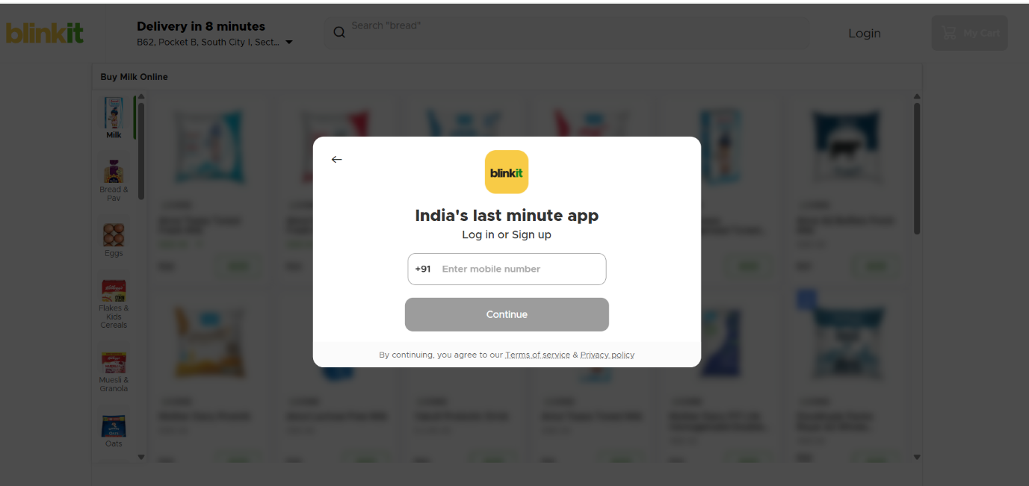

To reach this site customer should type [www.groceryshop.com](http://www.toyshop.com) on web browser he will see the web application. Then he should fill the necessary details and get registered.

**Log in:**



After registration user will see the log in page. He should type the correct user ID and password at right place and log in to the system. Then he will see the home page.

**Home page:**

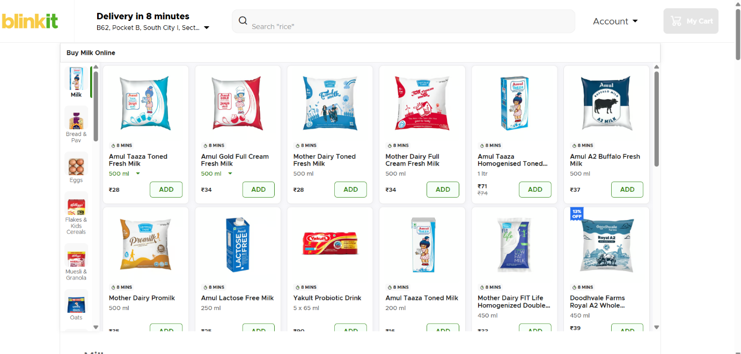

After login, the Home page will be visible to the user. On that page, users can search for the products. There is the option of a sort dropdown button on which you can sort the product according to the choice.

**Add to cart page:**

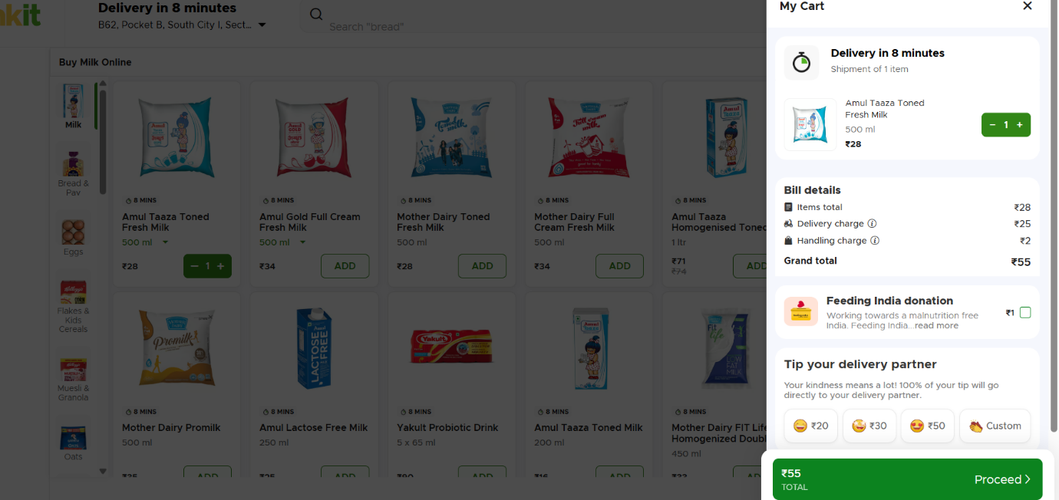

In this page, user can see the products which were added in the cart and they can proceed to address and payment.

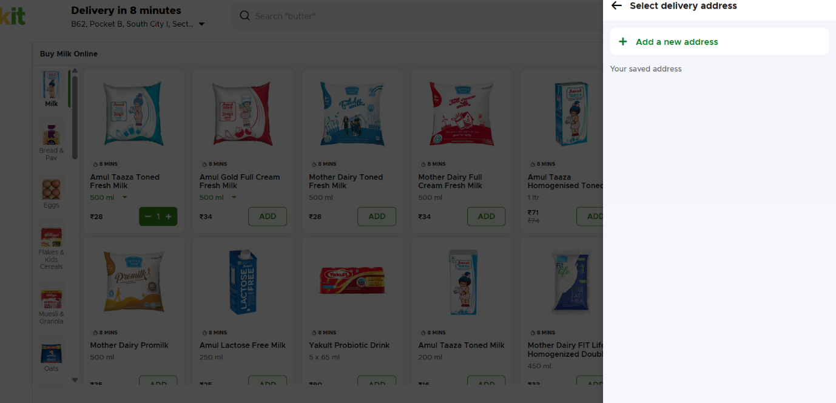

**Payment page:**



After adding address, user will see payment screen then he can pay the money and confirm the order.

|  |  |
| --- | --- |
| **Feature** | **Functionality** |
| Card payment | User can pay the money from card. |
| Net banking | User can pay the money by net banking. |
| Cash | User can pay the money by cash on delivery. |

# Project estimation:

**Admin portal:**

|  |  |  |  |
| --- | --- | --- | --- |
| **Module** | **Features** | **Back-end hours** | **Front-end hours** |
| Basic Setup | 1. Configuring AWS  2. environ Design database schemes  3. Code repository setup | 10 | 0 |
| Account | 1. Database table design  2. Admin login  3. Forgot password  4. Update data | 5 | 10 |
| Settings | 1. Add, view and edit manager and receptionist login IDs  2. Add. Update, delete product availability, , etc. | 5 | 5 |
| Customer Details | 1. Search customer details  2. Add, view customer information  3. View customer booking details | 5 | 5 |

**Content Manager portal:**

|  |  |  |  |
| --- | --- | --- | --- |
| **Module** | **Features** | **Back-end hours** | **Front-end hours** |
| Account | 1. Database table design  2. Forgot password  3. Update data | 5 | 10 |
| Settings | 1. Add, Update, and delete product availability, etc.  2. Create offers and discounts  3. View staff attendance | 5 | 5 |
| Customer Details | 1. Search for customer details  2. Add, view customer information  3. View customer booking details  4. Check-in and check-out | 5 | 5 |
| Reports | 1. Revenue reports  2. Capacity utilization report | 5 | 5 |

# Project team:

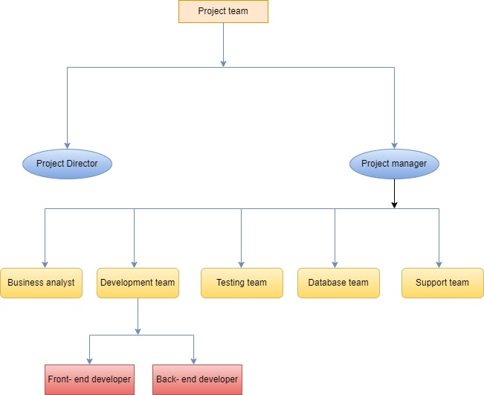

The project team for developing a grocery shop application consists of key roles ensuring a smooth transition from manual operations to a digital platform. The Business Analyst (BA) gathers requirements from stakeholders and ensures the application meets business needs. The Project Manager oversees timelines, resources, and risks. The UI/UX Designer creates an intuitive interface for a seamless shopping experience. The Developers (Frontend & Backend) build the application, integrating product catalogues, payment gateways, and order tracking features. The QA Testers ensure functionality and performance meet standards before launch. Finally, the Support & Maintenance Team handles post-launch updates and issue resolution. Effective collaboration among these roles provides a successful digital transformation for the grocery shop.

# Business Requirement document :

**Project name:** Grocery shop web application.

|  |  |  |  |  |  |
| --- | --- | --- | --- | --- | --- |
| **Version** | **Prepared by** | **Prepared date** | **Review by** | **Review date** | **Change log** |
| V1.0 | Rohit Dongare | 15/03/2025 | Mr. Omkar Pathak sir | 20/03/2025 | NA |
|  |  |  |  |  |  |
|  |  |  |  |  |  |

**1. Problem statement:**

**1.1 Less Customer Reach:**

The shop is located in a particular area, so the customer is not aware of that shop as well as every time they have to come in to buy grocerys, it is impossible to reach every customer in less time.

**1.2 Maintain data Manually:**

The client’s working procedure is manual for maintaining the records. It is time-consuming and difficult to use the data.

**1.3 Human Errors:**

Because of the complex business process, it is very difficult to update everything every time so it is difficult to track every single modification, payment information, and refund information.

**1.4 Refund process:**

Refund procedure is also hectic as well as time-consuming.

**1.5 Complicated cancellation process:**

If you want to cancel your purchased product in an emergency or any situation so you have to visit the shop for cancelling your grocery as well the full booking procedure is cancelled from scratch and it is really difficult to maintain this type of data.

**1.6 Time consuming process:**

Because of maintaining all data manually and maintaining hard copies it is really time-consuming.

**Project scope :**

The application will cater to customers looking to buy grocerys online and grocery shop owners managing their stores. The system will include user registration, a product catalogue, a shopping cart, a payment gateway, order tracking, and customer support functionalities.

Project scope document:

|  |  |  |  |
| --- | --- | --- | --- |
| **Product Features of Customer** | | | |
| **Category** | **Section** | **Actions** | **Sub-Actions** |
| **Authentication** | Login | Login | Enter credentials (email/username, password) & Authenticate. |
| **Purchase** | Purchase the product | Buy now | pay the money and add address |
| **Registration** | Register | Register | Submit registration details. |
| **Refund** | Demand for refund | Demand for refund | Enter refund reason |
| **Profile** | Edit Profile | Edit Profile | Change the necessary details and submit |
| **Order** | Create/Update/Delete Booking | Create/Update/Delete Booking | Edit the booking entter necessary details. |
| **Payment** | Create/Update Payement | Create/Update Payement | Enter payment method and proceed. |
| **Log out** | Log out | Log out | Press the log out button and confirm. |
| **Cart** | Add product to cart | Add product to cart | Add n number of products at same time and purchase it. |
| **View** | View products | View products | Home page you can view the products. |
| **Feedback** | Feedback | Feedback | Add feedback to textbox and submit. |
| **Contact** | Contact delivery boy by call | Contact delivery boy by call | You can chat with customer support. |
| **Cancellation** | Cancel Order | Cancel Order | Enter the reason for cancellation. |

|  |  |  |  |
| --- | --- | --- | --- |
| **Product Features of Admin** | | | |
| **Category** | **Section** | **Actions** | **Sub-Actions** |
| **Authentication** | Login | Login | Enter credentials (email/username, password) & Authenticate. |
| **Trancsactions** | Track transactions | Transactions | Click on view transactions. |
| **Registrations** | Register | Register | Submit registration details. |
| **Provide promocode** | Provide promocode | Go on promocode option | Enter credentials. |
| **Profile** | Edit Profile | Edit Profile | Change the necessary details and submit |
| **Holiday** | Create/Update/Delete Holiday | Create/Update/Delete Booking | Edit the holiday entter necessary details. |
| **Payment** | Create/Update Payement | Create/Update Payement | Enter payment method and proceed. |
| **Logout** | Log out | Log out | Press the log out button and confirm. |
| **Roles** | Create roles | Click on roles. | Enter necessary details. |
| **Product Features of Admin** | View products | View products | Home page you can view the products. |
| **Feedback** | Feedback | Feedback | Add feedback to textbox and submit. |
| **Purchase rate** | User purchase rate | User purchase rate |  |
| **Refund** | Update refund | Click on refund | Enter reason for refund and refund amount. |

|  |  |  |  |
| --- | --- | --- | --- |
| **Product Features of Customer support** | | | |
| **Category** | **Section** | **Actions** | **Sub-Actions** |
| **Authentication** | Login | Login | Enter credentials (email/username, password) & Authenticate. |
| **Read booking** | Bookings | Bookings | Read booking details |
| **Registration** | Register | Register | Submit registration details. |
| **Chat option** | Chat | Chat | Chat with customer |
| **Profile** | Edit Profile | Edit Profile | Change the necessary details and submit |
| **Mail** | Email | Email | Send mail |
| **Feedback** | Read feedback | Read feedback | Read feedback and respond. |
| **Log out** | Log out | Log out | Press the log out button and confirm. |
| **Alert** | Maintainance | Maintainance | Click on create alert. |
| **View** | View products | View products | Home page you can view the products. |
|  |  |  |  |

|  |  |  |  |
| --- | --- | --- | --- |
| **Product Features of Inventory support** | | | |
| **Category** | **Section** | **Actions** | **Sub-Actions** |
| **Authentication** | Login | Login | Enter credentials (email/username, password) & Authenticate. |
| **Products** | Track Number of products | Track Number of products | Click on Product details |
| **Registrations** | Register | Register | Submit registration details. |
| **Order products** | Order products | Order products | Click on order. |
| **Profile** | Edit Profile | Edit Profile | Change the necessary details and submit |
| **Holiday** | Take leave | Take leave | Apply for leave |
| **Edit product detials** | Edit product detials | Edit product detials | Edit product detials |
| **Logout** | Log out | Log out | Press the log out button and confirm. |
| **Availablility** | Availability of product | Availability of product | Check Availability of product |
| **Product Features** | View products | View products | Home page you can view the products. |
|  |  |  |  |

|  |  |  |  |
| --- | --- | --- | --- |
| **Product Features of accounts** | | | |
| **Category** | **Section** | **Actions** | **Sub-Actions** |
| **Authentication** | Login | Login | Enter credentials (email/username, password) & Authenticate. |
| **Products** | Track Number of products | Track Number of products | Click on Product details |
| **Registrations** | Register | Register | Submit registration details. |
| **Creating Budget report** | Creating Budget report | Creating Budget report | Click on budget report. |
| **Analysing Final accounts** | Analysing Final accounts | Analysing Final accounts | Click on final accounts |
| **Providing receipt** | Providing receipt | Providing receipt | Edit the holiday entter necessary details. |
| **Paying salary** | Paying salary | Paying salary | Enter payment method and proceed. |
| **Payment history** | Payment history | Payment history | Press the log out button and confirm. |

**3. As is business process:**

**a. UML diagram on high level:**

**Flowchart high-level:**

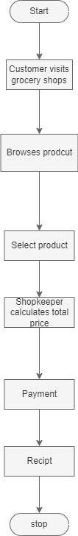

**Activity diagram high level:**

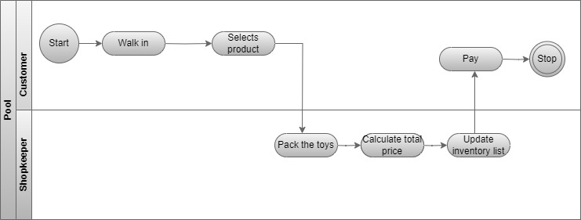

Customers visit the grocery shop physically, browse products, and select items they need. They may ask the shopkeeper about product availability and prices before proceeding to billing. The shopkeeper manually calculates the total cost, and the customer pays via cash, card, or digital wallet if available. After payment, the shopkeeper or an assistant packs the items, and the customer takes them home. If home delivery is available, the shopkeeper notes the customer’s address and assigns a delivery person, who delivers the groceries and collects payment if required. This manual process often leads to inefficiencies such as stock mismatches, long wait times, limited payment options, and lack of order tracking.

**b. To be a business process on a high level:**

**a. UML flowchart diagram on a high level:**

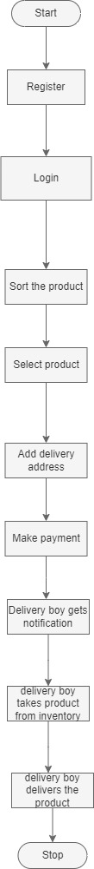

**Activity diagram high level:**

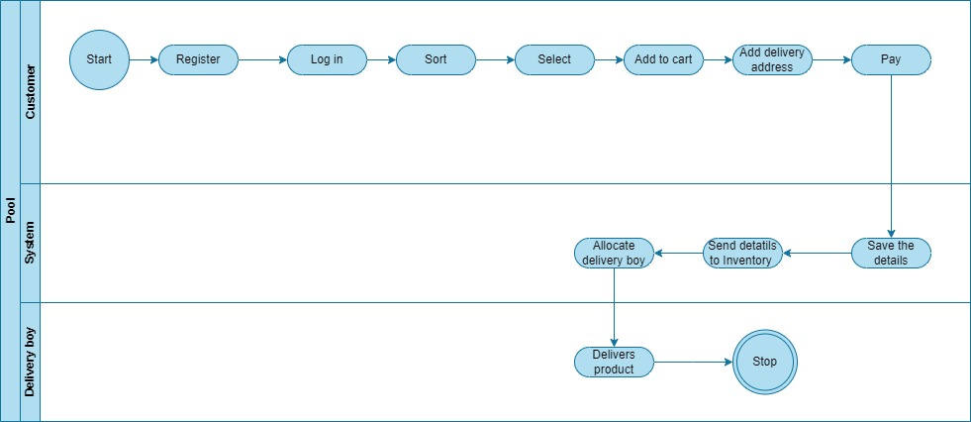

Customers can purchase groceries conveniently through a web application. They browse products, check real-time availability, and add items to their virtual cart. The system automatically calculates the total cost, and customers can choose from multiple secure payment options, including digital wallets, credit/debit cards, and cash on delivery. After order confirmation, the system updates the inventory and notifies the shopkeeper for processing. The order is then packed and either prepared for in-store pickup or assigned to a delivery person. Customers can track their orders in real-time and receive notifications on their order status. This streamlined digital process reduces wait times, minimizes errors, offers better inventory management, and enhances the overall shopping experience.

**UI screens:**

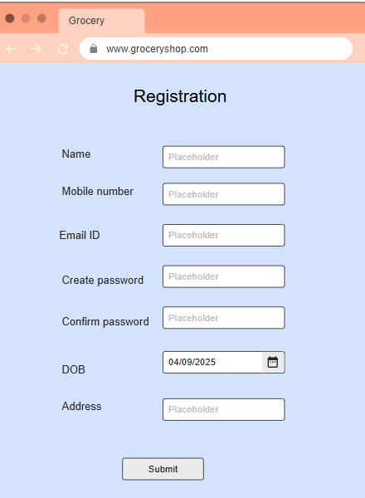

To reach this site customer should type [www.groceryshop.com](http://www.toyshop.com) on web browser he will see the web application. Then he should fill the necessary details and get registered.

**Log in:**

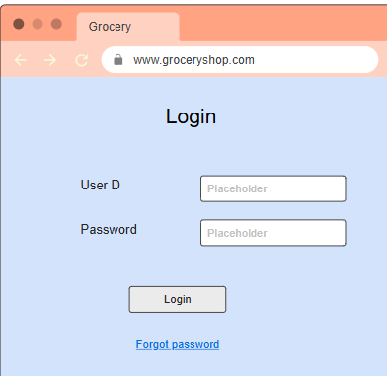

After registration user will see the log in page. He should type the correct user ID and password at right place and log in to the system. Then he will see the home page.

**Home page:**

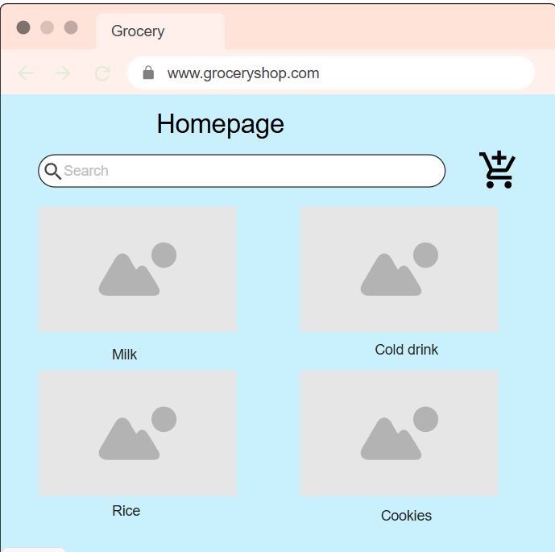

After login, the Home page will be visible to the user. On that page, users can search for the products. There is the option of a sort dropdown button on which you can sort the product according to the choice.

**Add to cart page:**

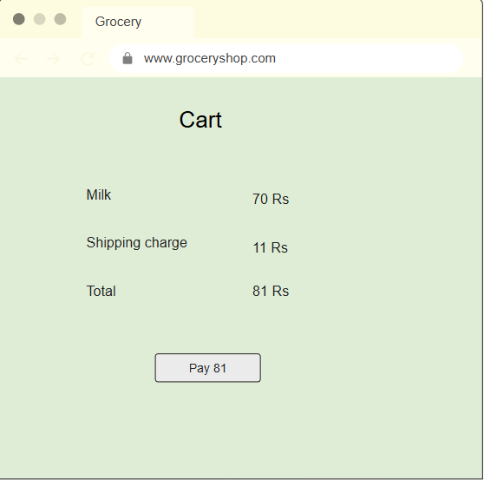

In this page, user can see the products which were added in the cart and they can proceed to address and payment.

**Payment page:**

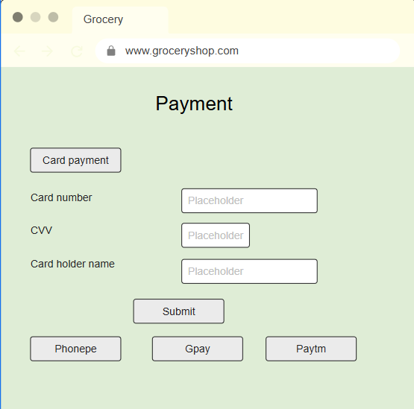

After adding the address, the user will see a payment screen then he can pay the money and confirm the order.

|  |  |
| --- | --- |
| **Feature** | **Functionality** |
| Card payment | User can pay the money from card. |
| Net banking | User can pay the money by net banking. |
| Cash | User can pay the money by cash on delivery. |

**Confirmation page:**

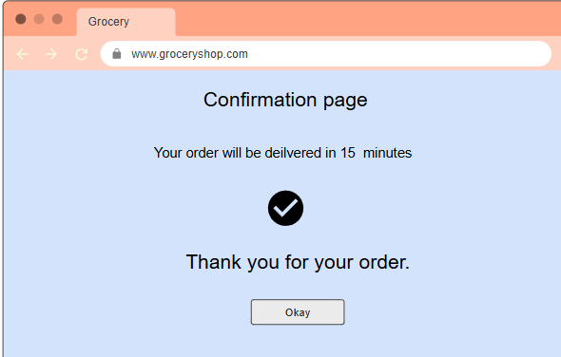

After payment confirmation page will be visible. It shows delivery time and confirmation message.

1. **Non-functional requirements:**
   1. **UI requirements:**

* User Interface requirement is simple and easy appearance
* The colour of the text, foreground, and background will be contrasted.
  1. **Software requirement:**
* Any operating system can be used with the help of an internet browser.
  1. **Hardware Requirement**
* Processor minimum i5 and HDD 250 GB/RAM minimum 8 GB.

1. **Assumptions and constraints:**

**1) Assumptions:**

* 1. Grocery shop application will be entirely managed by the administration.
  2. End users should be of 18+ age.
  3. Every user has an account created and authenticated by the administration.
  4. Unless the payment phase is completed, the system will not allow the booking capabilities.
  5. Grocery shop application will work on a server that needs to be always online.

**2) Constraints:**

1. Response time for loading the product should take no longer than five minutes.
2. Application size is 50 MB maximum.
3. All import data will be available in PDF, doc format.
4. Application language only in English.
5. Default currency type will be Indian rupees.

# Software requirement specifications

|  |  |  |  |  |  |
| --- | --- | --- | --- | --- | --- |
| **Version** | **Prepared by** | **Prepared date** | **Review by** | **Review date** | **Change log** |
| V1.0 | Rohit Dongare | 15/03/2025 | Mr. Omkar Pathak sir | 20/03/2025 | NA |
|  |  |  |  |  |  |
|  |  |  |  |  |  |

**1. Problem statement:**

**1.1 Less Customer Reach:**

The shop is located in a particular area, so the customer is not aware of that shop as well as every time they have to come in to buy grocerys, it is impossible to reach every customer in less time.

**1.2 Maintain data Manually:**

The client’s working procedure is manual for maintaining the records. It is time-consuming and difficult to use the data.

**1.3 Human Errors:**

Because of the complex business process, it is very difficult to update everything every time so it is difficult to track every single modification, payment information, and refund information.

**1.4 Refund process:**

Refund procedure is also hectic as well as time-consuming.

**1.5 Complicated cancellation process:**

If you want to cancel your purchased product in an emergency or any situation so you have to visit the shop for cancelling your grocery as well the full booking procedure is cancelled from scratch and it is really difficult to maintain this type of data.

**1.6 Time consuming process:**

Because of maintaining all data manually and maintaining hard copies it is really time-consuming.

**Project scope :**

The application will cater to customers looking to buy grocerys online and grocery shop owners managing their stores. The system will include user registration, a product catalog, a shopping cart, a payment gateway, order tracking, and customer support functionalities.

|  |  |  |  |
| --- | --- | --- | --- |
| **Product Features of Customer** | | | |
| **Category** | **Section** | **Actions** | **Sub-Actions** |
| **Authentication** | Login | Login | Enter credentials (email/username, password) & Authenticate. |
| **Purchase** | Purchase the product | Buy now | pay the money and add address |
| **Registration** | Register | Register | Submit registration details. |
| **Refund** | Demand for refund | Demand for refund | Enter refund reason |
| **Profile** | Edit Profile | Edit Profile | Change the necessary details and submit |
| **Order** | Create/Update/Delete Booking | Create/Update/Delete Booking | Edit the booking entter necessary details. |
| **Payment** | Create/Update Payement | Create/Update Payement | Enter payment method and proceed. |
| **Log out** | Log out | Log out | Press the log out button and confirm. |
| **Cart** | Add product to cart | Add product to cart | Add n number of products at same time and purchase it. |
| **View** | View products | View products | Home page you can view the products. |
| **Feedback** | Feedback | Feedback | Add feedback to textbox and submit. |
| **Contact** | Contact delivery boy by call | Contact delivery boy by call | You can chat with customer support. |
| **Cancellation** | Cancel Order | Cancel Order | Enter the reason for cancellation and cancel the order. |

|  |  |  |  |
| --- | --- | --- | --- |
| **Product Features of Admin** | | | |
| **Category** | **Section** | **Actions** | **Sub-Actions** |
| **Authentication** | Login | Login | Enter credentials (email/username, password) & Authenticate. |
| **Trancsactions** | Track transactions | Transactions | Click on view transactions. |
| **Registrations** | Register | Register | Submit registration details. |
| Provide promocode | Provide promocode | Go on promocode option | Enter credentials. |
| **Profile** | Edit Profile | Edit Profile | Change the necessary details and submit |
| **Holiday** | Create/Update/Delete Holiday | Create/Update/Delete Booking | Edit the holiday entter necessary details. |
| **Payment** | Create/Update Payement | Create/Update Payement | Enter payment method and proceed. |
| **Logout** | Log out | Log out | Press the log out button and confirm. |
| **Roles** | Create roles | Click on roles. | Enter necessary details. |
| **Product Features of Admin** | View products | View products | Home page you can view the products. |
| **Feedback** | Feedback | Feedback | Add feedback to textbox and submit. |
| **Purchase rate** | User purchase rate | User purchase rate |  |
| **Refund** | Update refund | Click on refund | Enter reason for refund and refund amount. |

|  |  |  |  |
| --- | --- | --- | --- |
| **Product Features of Customer support** | | | |
| **Category** | **Section** | **Actions** | **Sub-Actions** |
| **Authentication** | Login | Login | Enter credentials (email/username, password) & Authenticate. |
| **Read booking** | Bookings | Bookings | Read booking details |
| **Registration** | Register | Register | Submit registration details. |
| **Chat option** | Chat | Chat | Chat with customer |
| **Profile** | Edit Profile | Edit Profile | Change the necessary details and submit |
| **Mail** | Email | Email | Send mail |
| **Feedback** | Read feedback | Read feedback | Read feedback and respond. |
| **Log out** | Log out | Log out | Press the log out button and confirm. |
| **Alert** | Maintainance | Maintainance | Click on create alert. |
| **View** | View products | View products | Home page you can view the products. |

|  |  |  |  |
| --- | --- | --- | --- |
| **Product Features of Inventory support** | | | |
| **Category** | **Section** | **Actions** | **Sub-Actions** |
| **Authentication** | Login | Login | Enter credentials (email/username, password) & Authenticate. |
| **Products** | Track Number of products | Track Number of products | Click on Product details |
| **Registrations** | Register | Register | Submit registration details. |
| **Order products** | Order products | Order products | Click on order. |
| **Profile** | Edit Profile | Edit Profile | Change the necessary details and submit |
| **Holiday** | Take leave | Take leave | Apply for leave |
| **Edit product detials** | Edit product detials | Edit product detials | Edit product detials |
| **Logout** | Log out | Log out | Press the log out button and confirm. |
| **Availablility** | Availability of product | Availability of product | Check Availability of product |
| **Product Features** | View products | View products | Home page you can view the products. |
|  |  |  |  |

|  |  |  |  |
| --- | --- | --- | --- |
| **Product Features of accounts** | | | |
| **Category** | **Section** | **Actions** | **Sub-Actions** |
| **Authentication** | Login | Login | Enter credentials (email/username, password) & Authenticate. |
| **Products** | Track Number of products | Track Number of products | Click on Product details |
| **Registrations** | Register | Register | Submit registration details. |
| **Creating Budget report** | Creating Budget report | Creating Budget report | Click on budget report. |
| **Analysing Final accounts** | Analysing Final accounts | Analysing Final accounts | Click on final accounts |
| **Providing receipt** | Providing receipt | Providing receipt | Edit the holiday entter necessary details. |
| **Paying salary** | Paying salary | Paying salary | Enter payment method and proceed. |
| **Payment history** | Payment history | Payment history | Press the log out button and confirm. |

**As is the business process: (Low level)**

**Flowchart:**

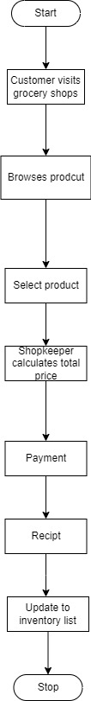

**Activity diagram:**

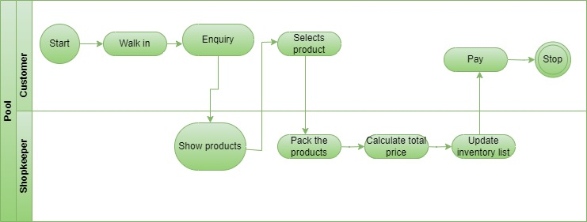

The customer physically visits the grocery store and begins browsing through the available products. If the customer has a shopping list, they manually search for each item; otherwise, they make purchase decisions on the spot. In case of difficulty finding an item, the customer asks the shopkeeper or store staff for assistance regarding product availability, pricing, or recommendations. Once all the required items are collected, the customer proceeds to the billing counter, where the shopkeeper manually calculates the total cost, often using a calculator or a basic point-of-sale (POS) system if available. If a product does not have a visible price tag, the shopkeeper may need to check a price list or refer to past knowledge, leading to potential delays.

At the billing counter, the customer makes the payment using cash, card, or digital wallets, depending on what the store accepts. If change is required for cash payments, additional time is spent handling currency. The shopkeeper may provide a paper receipt if a billing system is in place; otherwise, no formal proof of purchase is given. After payment, the shopkeeper or an assistant packs the groceries into bags, sometimes using plastic or paper bags based on customer preference or store policy. The customer then collects the packed items and leaves the store.

If the customer opts for home delivery, they provide their address and contact details to the shopkeeper, usually written manually or saved in a register or phone. The shopkeeper assigns a delivery person, who delivers the items at a later time. In the case of cash-on-delivery orders, the delivery person collects payment upon arrival. Since no automated tracking system exists, customers must call the shopkeeper for order updates. This entire manual process can lead to inefficiencies such as stock mismatches, longer wait times, pricing discrepancies, delayed deliveries, and lack of order transparency.

**To be a low-level business process:**

**Flow chart:**

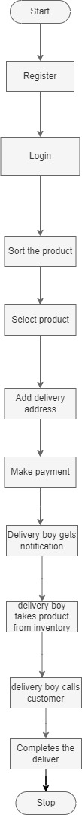

**Activity diagram:**

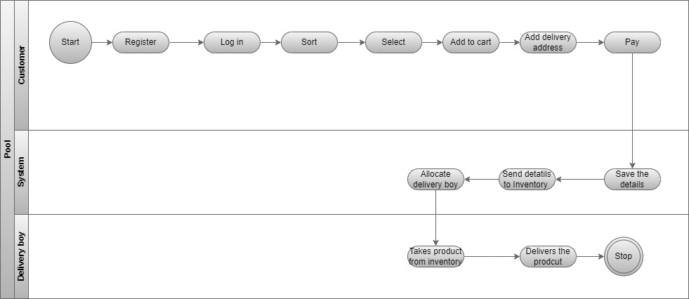

In the proposed system, customers can conveniently shop for groceries through a web application. They begin by logging into their account or browsing as a guest. The application provides an intuitive interface where customers can search for products using categories, filters, or a search bar. Each product displays real-time stock availability, pricing, discounts, and detailed descriptions. Customers can add desired items to their virtual cart, review their selections, and modify quantities as needed. The system also suggests related or frequently bought-together items based on previous purchases or popular trends.

Once the shopping list is finalized, customers proceed to checkout, where they select a preferred delivery method—either home delivery or in-store pickup. They then choose from multiple payment options, including credit/debit cards, digital wallets, UPI, or cash on delivery. If digital payment is selected, a secure payment gateway processes the transaction, and the customer receives an instant confirmation via email and app notifications. The system automatically updates inventory to reflect the order and generates a digital invoice for reference.

For home delivery, the system assigns the order to a delivery personnel based on location and availability. Customers can track their order in real time, receiving notifications at key stages—order processing, packaging, dispatch, and delivery. The delivery agent follows an optimized route for efficient drop-offs. Upon delivery, the customer may be required to confirm receipt via a digital signature or OTP verification. If issues arise, such as missing or damaged items, customers can raise complaints through the app, and the support team handles refunds or replacements seamlessly.

For in-store pickup, the customer receives a notification once the order is ready. They visit the store, verify their order number, and collect the pre-packed groceries, reducing in-store wait times. The system maintains a record of purchases, enabling personalized promotions, loyalty rewards, and analytics-driven insights for better customer engagement. This automated process improves efficiency, minimizes errors, enhances customer experience, and ensures smooth inventory and order management.

**Functional specifications:**

**Use case diagrams:**

**Customer:**

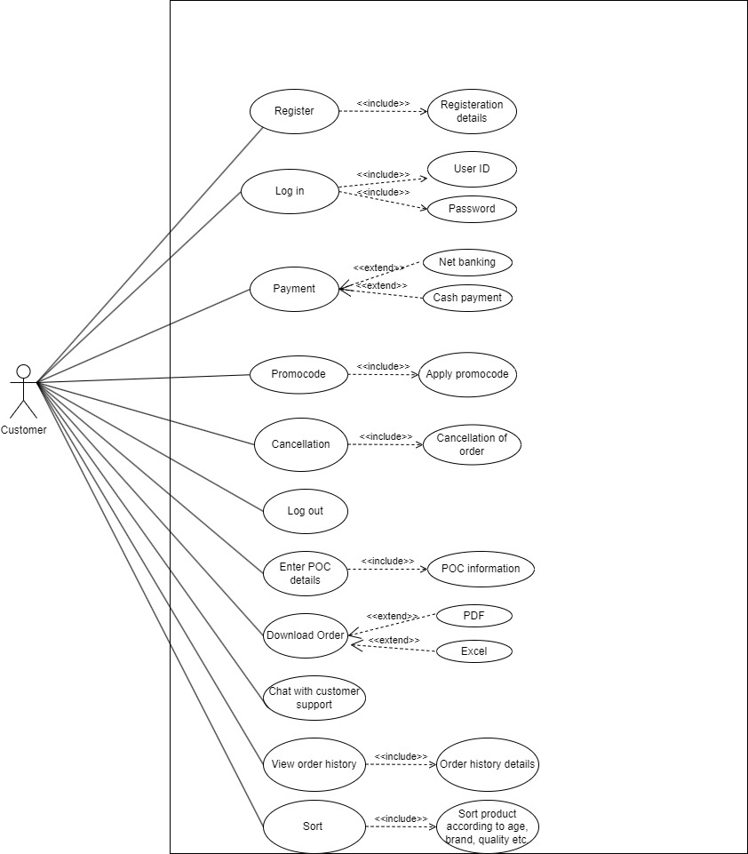

**Admin:**

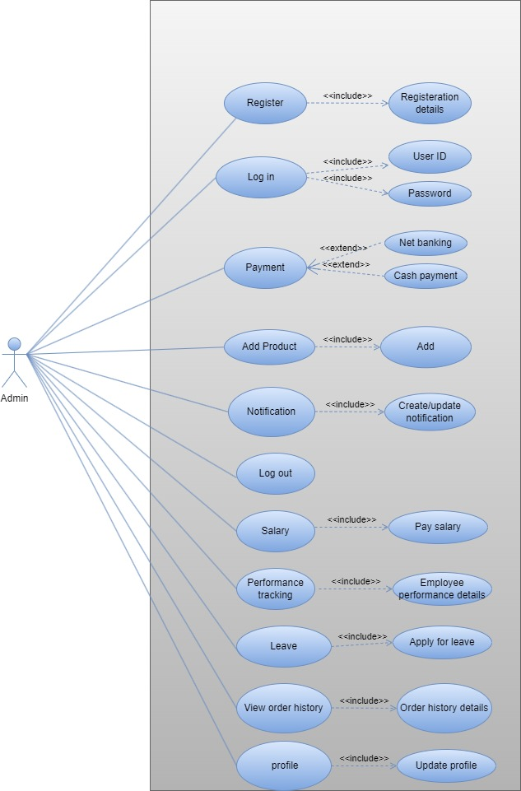

**Content manager:**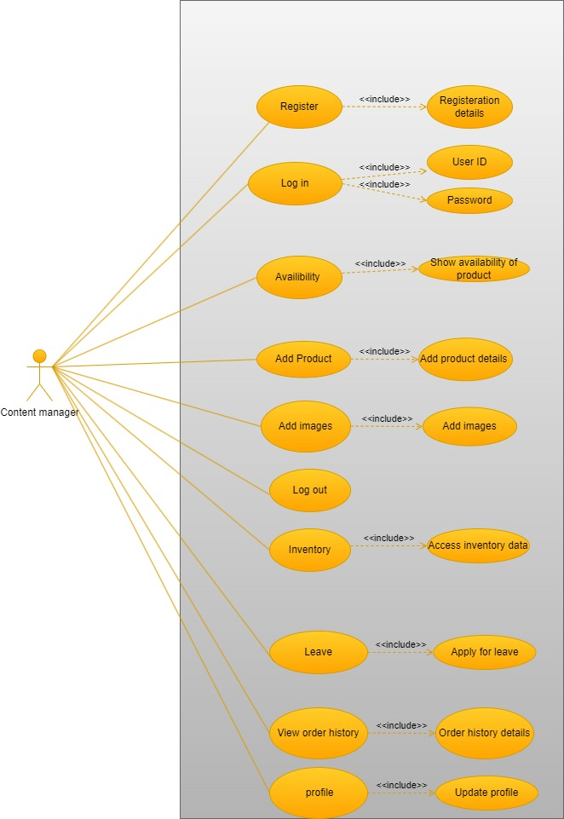

**Inventory manager:**

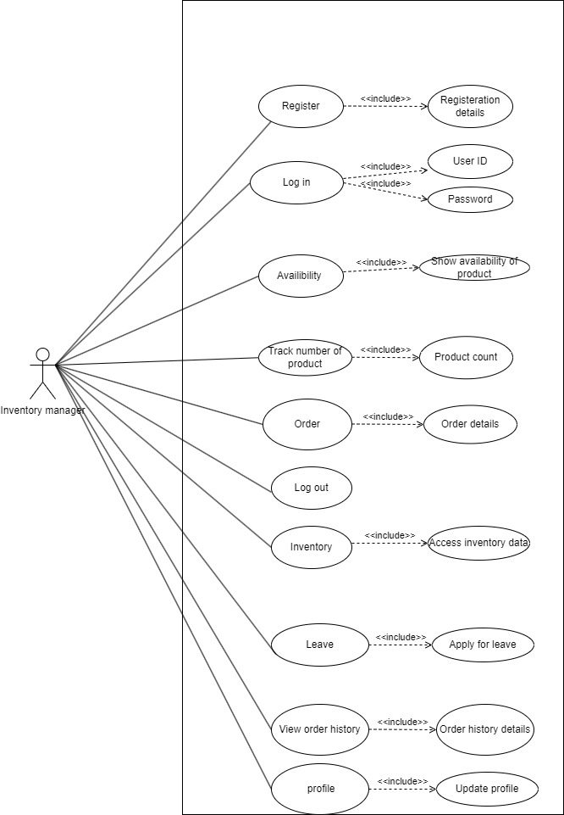

**Customer support:**

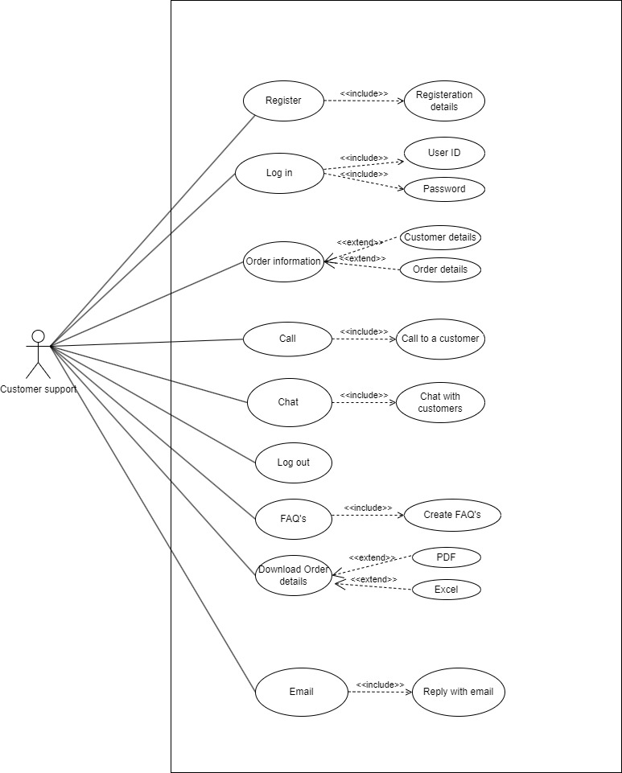

**Data flow diagram:**

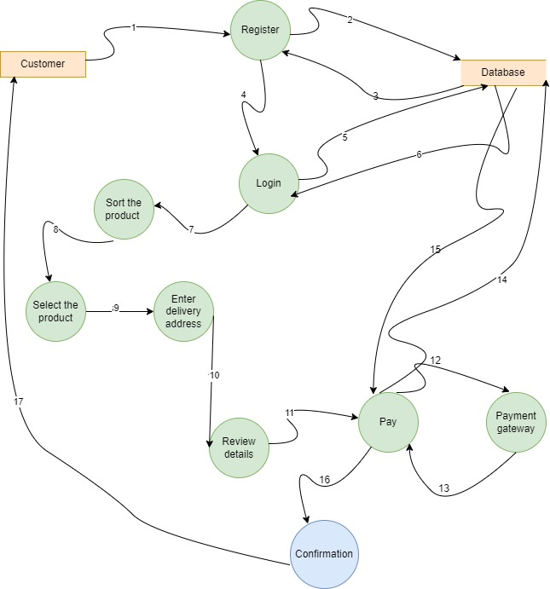

The Data Flow Diagram (DFD) illustrates the process of purchasing a grocery from an online application. The customer selects a grocery, adds it to the cart, and proceeds to checkout. The application checks stock availability with the Inventory System and confirms it before processing the payment through the Payment Gateway. Upon successful payment, the order details are saved in the Order Database, and stock updates are made in the Inventory Database. The application then requests shipping from the Shipping Provider, which updates the Shipping Database and provides tracking details. Finally, the customer receives an order confirmation along with tracking information.

**Sequence diagram:**

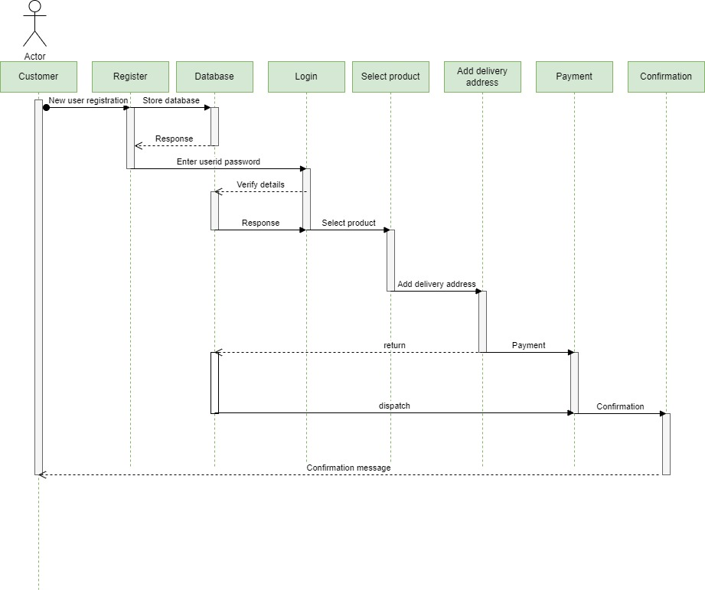

The sequence diagram illustrates the process of a customer purchasing a grocery from an online application. The interaction begins when the customer browses and selects a grocery, adds it to the cart, and proceeds to checkout. The application then checks stock availability with the inventory system. If stock is confirmed, the customer initiates payment, which is processed through the payment gateway. Upon successful payment, the application confirms the order, updates the inventory, and requests shipping from the shipping provider. Once the shipping provider dispatches the order, the application updates the customer with tracking details, completing the purchase process.

**Use case specifications:**

**Registration:**

|  |  |  |  |  |  |  |  |  |  |  |  |
| --- | --- | --- | --- | --- | --- | --- | --- | --- | --- | --- | --- |
| Use Case ID: | | | | | Ucid001 | Prepared By | | | Rohit Dongare | | |
|  | | | | | | Prepared Date | | | --/--/---- | | |
| Use Case Name: New user can register. | | | | | | | | | | | |
| Use case Diagram: | | | | | | | | | | | |
| **Actors:** New user | | | | | | | | | | | |
| **Pre -Condition** | | | | | | | | | | | |
| 1. User must be 18+ | | | | | | | | | | | |
| **Successful Post Condition** | | | | | | **Unsuccessful Post Condition** | | | | | |
| 1. Show pop-up window with message ‘user registration is successful’ 2. Click on ok button navigate to login page. | | | | | | 1. User stay on registration page 2. Show validation message below field name in color red font arial size 10. 3. Please refer validation message in field validation table. | | | | | |
| **Basic Flow** | | | | | | **Alternate flow** | | | | | |
| 1. Click on register link in top right corner of home page. 2. User enters mandatory fields. 3. Click on ‘submit’ button | | | | | | 1. Click on register link on footer and pre payment page. 2. Fill mandatory fields. 3. Click on submit button. | | | | | |
| **Field Validation Table** | | | | | | | | | | | |
| Sr. No | Field Name | Control type | Data type | Length | Default Value | Other Value | Functional Requirement | Business Rule | | Validation Role | Validation Message |
| 1 | Name | Text Box | Character | 50 | Please Enter your name | NA | Please Enter Username | NA | | 1.Mandatory | For validation Rule 1 show below message. ‘Please enter name’ |
| 2.No Space Before/After/ inbetween | For validation Rule 2 show below message. ‘Please enter name without  space’ |
| 3.Character only | For validation Rule 3 show below message. ‘Please enter character  only’ |
| 2 | Mobile number | Text Box | Numeric | 10 | Please Enter mobile numner | NA | Please Enter mobile numner | NA | | 1.Mandatory | For validation Rule 1 show below message. ‘Please enter  OTP |
| 2.No Space Before/After/ in-between | For validation Rule 2 show below message. ‘Please enter OTP  without space’ |
| 3.Numeric only | For validation Rule 3 show below message. ‘Please enter  Numeric value only’ |
| 3 | OTP | Text Box | Numeric | 6 | Please Enter OTP | NA | Please Enter OTP | NA | | 1.Mandatory | For validation Rule 1 show below message. ‘Please enter  OTP |
| 2.No Space Before/After/ in-between | For validation Rule 2 show below message. ‘Please enter OTP  without space’ |
| 3.Numeric only | For validation Rule 3 show below message. ‘Please enter  Numeric value only’ |
| 4 | Password | Text Box | Alphanumeric | 8 | Please Enter Password | NA | Please Enter Password | NA | | 1.Mandatory | For validation Rule 1 show below message. ‘Please enter  Password’ |
| 2.No Space Before/After/ in-between | For validation Rule 2 show below message. ‘Please enter Password  without space’ |
| 3.Alphanumer ic only | For validation Rule 3 show below message. ‘Please enter  Alphanumeric only’ |
| 5 | Address | Text Box | Alphanumeric | 150 | Please enter address | NA | Please enter address | NA | | 1.Mandatory | For validation Rule 1 show below message. ‘Please enter  Address’ |
| 2.Space Before/After/ in-between | For validation Rule 2 show below message. ‘Please enter address  without space’ |
| 3.Alphanumer ic only | For validation Rule 3 show below message. ‘Please enter  Alphanumeric only’ |
| 6 | Submit button | Button | _- | _- | - | _- | - | _- | | 1. Mandatory | For validation, Rule 1 shows the below message. ‘Add to cart the product to purchase it,’  .’ |
|  |  |  |  |  |  |  |  |  | | 2.No Space Before/After/ in-between | For validation Rule 2 show below message. ‘Please enter Password  without space’ |
|  |  |  |  |  |  |  |  |  | | 3.Alphanumer ic only | For validation Rule 3 show below message. ‘Please enter  Alphanumeric only’ |

Use Case Specification (User Login)

|  |  |  |  |  |  |  |  |  |  |  |  |
| --- | --- | --- | --- | --- | --- | --- | --- | --- | --- | --- | --- |
| Use Case ID: | | | | | Ucid01 | Prepared By | | | Rohit Dongare | | |
|  | | | | | | Prepared Date | | | --/--/---- | | |
| Use Case Name: Existing User can Login | | | | | | | | | | | |
| Use case Diagram: | | | | | | | | | | | |
| Actors: Existing User | | | | | | | | | | | |
| **Pre -Condition** | | | | | | | | | | | |
| 1. User must have valid username & password | | | | | | | | | | | |
| **Successful Post Condition** | | | | | | **Unsuccessful Post Condition** | | | | | |
| 1. User must be logged into the system 2. User must navigate to car booking page | | | | | | 1. User stay on Login page 2. User enters the wrong username & password 3. Validation message is shown to user below field name in color ‘Red’ font ‘Arial’ size 10 4. 4. Refer validation message in validation table | | | | | |
| **Basic Flow** | | | | | | **Alternate flow** | | | | | |
| 1. System displays a Login page 2. User enters a correct username & password 3. Click on ‘Login’ button | | | | | | Not Applicable | | | | | |
| **Field Validation Table** | | | | | | | | | | | |
| Sr. No | Field Name | Control type | Data type | Length | Default Value | Other Value | Functional Requirement | Business Rule | | Validation Role | Validation Message |
| 1 | Username | Text Box | Character | 10-50 | Please Enter User name | NA | Please Enter Username | NA | | 1.Mandatory | For validation Rule 1 show below message. ‘Please enter  Username’ |
| 2.No Space Before/After/ inbetween | For validation Rule 2 show below message. ‘Please enter Username without  space’ |
| 3.Character only | For validation Rule 3 show below message. ‘Please enter character  only’ |
| 2 | Password | Text Box | Alphanumeric | 8 | Please Enter Password | NA | Please Enter Password | NA | | 1.Mandatory | For validation Rule 1 show below message. ‘Please enter  Password’ |
| 2.No Space Before/After/ in-between | For validation Rule 2 show below message. ‘Please enter Password  without space’ |
| 3.Alphanumer ic only | For validation Rule 3 show below message. ‘Please enter  Alphanumeric only’ |

**Use case specifications to add to cart the product**

|  |  |  |  |  |  |  |  |  |  |  |  |  |  |
| --- | --- | --- | --- | --- | --- | --- | --- | --- | --- | --- | --- | --- | --- |
| **Use Case ID:** | | | Ucid035 | | | | **Prepared By** | | | | Rohit Dongare | | |
|  | | | | | | | **Prepared Date** | | | | --/--/---- | | |
| **Use Case Name:** Sort the product and add to cart. | | | | | | | | | | | | | |
| **Use case diagram:** | | | | | | | | | | | | | |
| **Actors:** Existing Customer | | | | | | | | | | | | | |
| **Pre -Condition** | | | | | | | | | | | | | |
| 1. The user must be login to the system. | | | | | | | | | | | | | |
| **Successful Post Condition** | | | | | | | **Unsuccessful Post Condition** | | | | | | |
| 1. The user sorts the products according to age, price, and brands on the home page. 2. Select the product and add it to cart. | | | | | | | 1. The user stays on home page and sorts the product wrongly. 2. Validation message shown to user below field name in color ‘Red’ font ‘Arial’ size 10. | | | | | | |
| **Basic Flow** | | | | | | | **Alternate flow** | | | | | | |
| 1. The user sorts the products according to age, price, and brands on the home page. 2. Select the product and add it to cart. | | | | | | | Not applicable | | | | | | |
| Field Validation Table | | | | | | | | | | | | | |
| Sr.No | Field  Name | Control  type | | Data  type | Length | Default  Value | | Other  Value | Functional  Requirement | Business  Rule | | Validation  Rule | Validation  Message |
| 1 | Sort button | Drop down Button | | _ | _ | _ | | _ | - | _ | | 1. Mandatory | For validation, Rule 1 shows the below message. ‘Please sort  The products according to your choice.’ |
| 2 | Add to cart button | Button | | _ | _ | _ | | _ | - | _ | | 1. Mandatory | For validation, Rule 1 shows the below message. ‘Add to cart the product to purchase it,’  .’ |

**Use case specification to add the address:**

|  |  |  |  |  |  |  |  |  |  |  |  |  |  |
| --- | --- | --- | --- | --- | --- | --- | --- | --- | --- | --- | --- | --- | --- |
| **Use Case ID:** | | | Ucid02 | | | | **Prepared By** | | | | Rohit Dongare | | |
|  | | | | | | | **Prepared Date** | | | | --/--/---- | | |
| **Use Case Name:** Add delivery address. | | | | | | | | | | | | | |
| **Use case diagram:** | | | | | | | | | | | | | |
| **Actors:** Existing Customer | | | | | | | | | | | | | |
| **Pre -Condition** | | | | | | | | | | | | | |
| 1. The user must be login to the system. | | | | | | | | | | | | | |
| **Successful Post Condition** | | | | | | | **Unsuccessful Post Condition** | | | | | | |
| 1. Customer should click on proceed. 2. Add address screen open’s up. | | | | | | | 1. The user stays on Add to cart page. 2. Validation message shown to user below field name in color ‘Red’ font ‘Arial’ size 10. | | | | | | |
| **Basic Flow** | | | | | | | **Alternate flow** | | | | | | |
| 1. Customer should click on proceed. 2. Add address screen open’s up. | | | | | | | Not applicable | | | | | | |
| Field Validation Table | | | | | | | | | | | | | |
| Sr.No | Field  Name | Control  type | | Data  type | Length | Default  Value | | Other  Value | Functional  Requirement | Business  Rule | | Validation  Rule | Validation  Message |
| 1 | Address | Text box | | Alphanumeric | 50 | Please enter address | | NA | Please enter address | NA | | 1. Mandatory | For validation, Rule 1 shows the below message. ‘Please Enter your address.’ |
| 2 | Submit button | Button | | _ | _ | _ | | _ | - | _ | | 1. Mandatory | For validation, Rule 1 shows the below message. ‘Please submit your address,’  .’ |

|  |  |  |  |  |  |  |  |  |  |  |  |  |  |
| --- | --- | --- | --- | --- | --- | --- | --- | --- | --- | --- | --- | --- | --- |
| **Use Case ID:** | | | Ucid05 | | | | **Prepared By** | | | | Rohit Dongare | | |
|  | | | | | | | **Prepared Date** | | | | --/--/---- | | |
| **Use Case Name:** Existing User should payment | | | | | | | | | | | | | |
| **Use case diagram:** | | | | | | | | | | | | | |
| **Actors:** Existing Customer | | | | | | | | | | | | | |
| **Pre -Condition** | | | | | | | | | | | | | |
| 1. User must be registered user 2. User must be selected their date, location and whatever they want a type of car. 3. User must be following complete booking procedure. | | | | | | | | | | | | | |
| **Successful Post Condition** | | | | | | | **Unsuccessful Post Condition** | | | | | | |
| 1. After car booking show payment screen 2. Show all payment gateways option in payment screen 3. Show OTP text field wherever it is necessary. 4. Show captcha option 5. Show pop-up window with message “Payment Successful”. | | | | | | | 1. Disable selection of payment options as per choice. 2. Without booking car you redirected on payment page. 3. Server issue occurs in bank. | | | | | | |
| **Basic Flow** | | | | | | | **Alternate flow** | | | | | | |
| 1. Select payment procedure as per your choice (DC, CC,Wallets and UPI). 2. Enter the credentials 3. Click on “submit ” button. | | | | | | | NA | | | | | | |
| **Field Validation Table** | | | | | | | | | | | | | |
| **Sr.No** | **Field**  **Name** | **Control**  **type** | | **Data**  **type** | **Length** | **Default**  **Value** | | **Other**  **Value** | **Functional**  **Requirement** | **Business**  **Rule** | | **Validation**  **Rule** | **Validation**  **Message** |
| 1 | Mode of payment | Radio button | | Boolean | - | Debit Card | | NA | Whether user is able to select the particular payment mode. | NA | | 1. Mandatory 2. you can select only one option at a time. | For validation rule 1 show “Please select any payment mode”  For validation rule 2  Unable to select multiple options. |
| 3 | Select Time | Dropdown | | Selection | - | Select Time | | HH:MM AM/PM | Click on Select Time | NA | | 1.Mandatory | For validation Rule 1 show below message. ‘Please Select  Valid Time’ |
| 4 | Select Date | Dropdown | | Selection | - | Select Date | | dd/mm/yy | Click on Select Date | NA | | 1.Mandatory | For validation Rule 1 show below message. ‘Please Select  Valid Date’ |